PEI Potato Blossom Festival

Car Show & Shine 2019

Sunday, July 21st

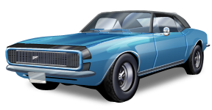

O’Leary Centennial Park 1 pm – 4 pm

Admission $ 5

Under 12 is FREE

Cars, Trucks, Motorcycles, Tractors

Engines and Snowmobiles

Registration for Participants 11 am – 1 pm

$10 per first Vehicle / $5 for second

Awards and Prizes

50/50 Music BBQ

Rain Date: July 28th/2019

